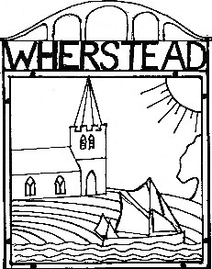

WHERSTEAD   
NEIGHBOURHOOD PLAN CONSULTATION QUESTIONNAIRE

Have Your Say!

Wherstead Parish Council believes that producing our own Neighbourhood Plan will give all residents an important say in the future development of our Parish. But we will need the full support of the residents, and in some cases your help to produce an effective Plan.

A Neighbourhood Plan allows local communities to shape and influence new development in their Parish by defining policies that must be taken into consideration by the District Council when assessing planning applications.

We need to know in what kind of village you see yourself living in and handing on to future generations. By completing this questionnaire, you will provide vital information for inclusion in local planning and development policies, helping safeguard the long-term future of our village.

This questionnaire can be completed by all occupants of the village who are **over the age of 16**.

This questionnaire can be completed on line at <https://www.smartsurvey.co.uk/s/QJ5DZ0/>

**Please use the on-line version if possible as it will significantly help us to analyse the results.**

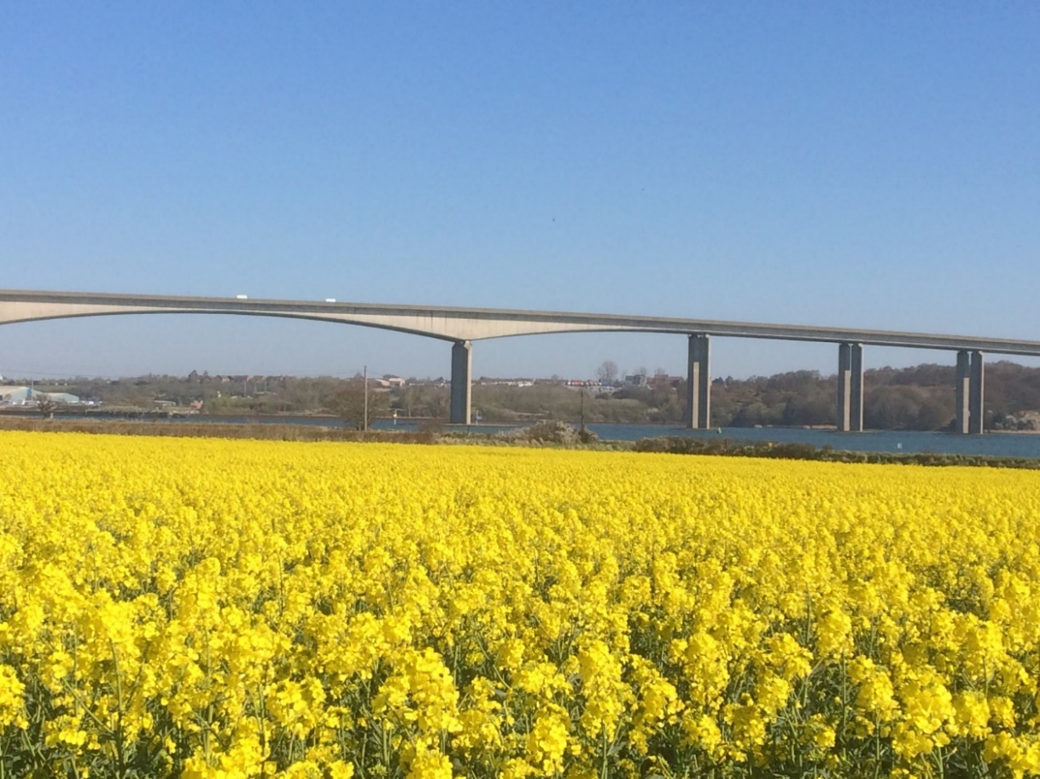

If you need extra paper copies of the questionnaire, please contact Robin Coates tel. 0784 0610856 or email [NeighbourhoodPlan@Whersteadpc.co.uk](mailto:NeighbourhoodPlan@Whersteadpc.co.uk)

Please complete the online version or return paper copies by **20th December 2020** to one of the following:

1. Birch Tree Cottage, The Street, Wherstead
2. Restholme, The Strand, Wherstead
3. The Haven, Bourne Hill, Wherstead

If you would like your completed copy collected please contact Helen Fawthrop tel 07762170128

If you would like assistance or have any questions, please contact Robin Coates tel. 0784 0610856

**THE FUTURE OF WHERSTEAD**

The following four-part vision statement for the future of Wherstead has been created after discussion with residents:

* The village landscape, with its many historic and listed structures and links back to Wherstead’s past, is maintained.
* Links between the two population centres of the village are strengthened and the more remote homes in the village retain their setting and independence.
* Wherstead’s separate identity from Ipswich and the surrounding villages is maintained.
* The unique, distinct character of the village is maintained by ensuring additional housing and business development is in proportion to the current size and needs of the Parish.

1. Please confirm if you support these statements: Agree    Disagree 

|  |
| --- |
| Please add comments to enhance any of these statements or add to the vision of Wherstead. |

Please see information sheet on page 8.

**ABOUT YOU**

1. Which age group are you in?(tick one box)

|  |  |  |  |  |  |
| --- | --- | --- | --- | --- | --- |
| 16 – 18 |  | 19 - 25 |  | 26 - 45 |  |
| 46 – 65 |  | 66+ |  | Prefer not to say |  |

1. Please provide your Wherstead postcode in the box.

|  |  |
| --- | --- |
| Post code | **IP** |
| Name (optional) |  |

1. What do you cherish about living in Wherstead? (tick all that apply)

|  |  |  |  |  |
| --- | --- | --- | --- | --- |
| Sense of community | |  | Open views over fields, woods, AONB |  |
| Easy access to countryside | |  | Historic setting |  |
| Rural nature with proximity to amenities | |  | Safe place to live |  |
| Suitable range of housing | |  | Friendly |  |
| Other, please state here |  | | | |

.

|  |
| --- |
| If there is anything you dislike about living in Wherstead please tell us here |

**YOUR VIEWS ON HOUSING DEVELOPMENT**

1. Given the 75 new homes being built on Klondyke field, what further, if any, type of housing growth/development should be permitted and where should it be?

|  |
| --- |
|  |

1. If you think there should be some housing development in Wherstead, what type of homes should be built? (tick all that apply)

|  |  |  |  |  |  |
| --- | --- | --- | --- | --- | --- |
| Terraced |  | Semi-detached |  | Detached |  |
| 1 Bedroom |  | Flats |  | Shared owner |  |
| 2 Bedroom |  | Bungalows |  | Rental |  |
| 3 Bedroom |  | 2 Storey |  | Social |  |
| 4 or more bedroom |  | 3 Storey |  | Self build |  |

1. If you think there should be some development of housing in Wherstead, what type should construction be? (tick all that apply)

|  |  |  |  |
| --- | --- | --- | --- |
| Modern |  | Designed to blend with neighbouring property |  |
| Mock period / traditional |  | Homes with rights & space to keep chickens, horses etc. |  | |

1. Do you think the Plan should specify that new homes should have the following? (tick all that apply)

|  |  |  |  |  |  |
| --- | --- | --- | --- | --- | --- |
| Off road parking | |  | A minimum proximity to adjacent buildings |  | |
| Electric charging points for cars | |  | Minimum room size |  | |
| Other, please specify |  | | | |  |

1. Please identify any areas and views within the Parish that you think should be protected from development and give your reason. e.g. Area of Outstanding Natural Beauty (AONB), view from Bourne Hill towards the Orwell, outside the settlement boundary, Site of Special Scientific Interest (SSSI) at the northern end of Bobbits Lane, etc. (please see information sheet for details)

|  |  |
| --- | --- |
| Area | Reason |
|  |  |
|  |  |
|  |  |
|  |  |

**YOUR VIEWS ON BUSINESS DEVELOPMENT**

The village has many existing businesses, together with a number of sites where further business development is proposed. (please see information sheet for details)

1. In addition to those developments with planning permission, are you in favour of any more business expansion within the village? Yes  No  Not sure 
2. What sorts of additional business premises would be acceptable? (tick all that apply)

|  |  |  |  |
| --- | --- | --- | --- |
| New build, green field sites |  | New build, brown field sites |  |
| Working from home |  | Refurbishment / repurposing of existing facilities |  |
| None of these |  |  |  |

1. What types of business expansion would be acceptable? (tick all that apply)

|  |  |  |  |
| --- | --- | --- | --- |
| Agricultural |  | Retail |  |
| Warehouse / trade counter / light industrial |  | Hospitality / tourism / leisure |  |
| Offices |  | Energy |  |
| Social care/care homes |  | None |  |

1. What scale of new business premises would be acceptable, in terms of the numbers of persons involved including staff, visitors, customers, deliveries etc.? (tick all that apply)

|  |  |  |  |
| --- | --- | --- | --- |
| Very large (greater than 200 people per day) |  | Large (30 – 200 people per day) |  |
| Medium (10 – 29 people per day) |  | Small (5 - 10 people per day) |  |
| Very small (less than 5 people per day) |  | None |  |

|  |
| --- |
| Do you have any further comments on business development within the village? |

# YOUR VIEWS ON MOVEMENT, TRANSPORT AND CONNECTIVITY

1. How far do you normally travel to work or place of study? 0 miles  1-5 miles  5-10 miles  15+ miles

|  |  |  |  |
| --- | --- | --- | --- |
| Not in work / study |  | Work / study from home |  |

1. How do you travel to your place of work or study?

|  |  |  |  |  |  |
| --- | --- | --- | --- | --- | --- |
| Work from home |  | Walk |  | Cycle |  |
| Car / motorbike |  | Public transport |  | N/A |  |
| School bus |  |  |  |  |  |

1. Do the bus routes take you where you need to go at appropriate times? Yes  No  Don’t know 

|  |
| --- |
| If no, please give details of your requirement |

1. How often do members of your household use local bus services or school bus?

|  |  |  |  |  |  |  |  |
| --- | --- | --- | --- | --- | --- | --- | --- |
| Daily |  | Once or twice a week |  | Weekends |  | Never |  |

1. Has COVID 19 changed your use of the local bus services? No     Increased  Decreased 
2. Bus stops and shelters

|  |  |
| --- | --- |
| 1. Are the stops conveniently located? | Yes   No  Don’t know  |
| 1. Is the shelter provided adequate? | Yes   No  Don’t know  |

1. Street lighting

|  |  |  |  |
| --- | --- | --- | --- |
| Is this adequate? | Yes   No  No opinion  | In the right place? | Yes  No  No opinion  |
| Causing excess light pollution? | Yes   No  No opinion  |  |  |

1. Wherstead attracts many visitors; do you consider the places used for parking as a problem? Yes   No  No opinion 

|  |
| --- |
| If yes, please give details |

1. Do broadband speeds need to be improved? Yes   No  No opinion 
2. Would you support any of the following?
   1. Enhanced maintenance of existing pavements Yes   No  No opinion 
   2. Designated cycle routes/cycle lanes for pleasure Yes   No  No opinion 
   3. Designated cycle routes/cycle lanes for connection within the village Yes   No  No opinion 
   4. Designated cycle routes/cycle lanes for connection to other villages and Ipswich Yes   No  No opinion 
   5. Safer crossings for the A14 slip roads Yes   No  No opinion 
   6. Reduced speed limits Yes   No  No opinion 

|  |
| --- |
| Location for reduced speed limits |

1. Public rights of way
   1. Would you support improvements to public rights of way (footpaths and bridleways) Yes   No  No opinion 
   2. Is the footpath / bridleway signage adequate and clear? Yes  No  Don't know 
   3. Do you know of any footpaths within the Parish that cannot be used 12 months of the year?

|  |
| --- |
| Please give details |

1. Would any of the above, bus, footpath, cycle routes or public rights of way improvements change the way you travel?  
    Yes  No  Don't know 
2. Do you have concerns about HGV / articulated traffic using The Street / Vicarage Lane? Yes   No  No opinion 
3. Would you support designating any qualifying roads as Quiet Lanes? (pleasesee information sheet for definition) Yes   No  No opinion 

|  |
| --- |
| If you have anything further to add about transport and highways**,** please tell us here: |

# YOUR VIEWS ON THE HISTORIC AND NATURAL ENVIRONMENT

1. The Neighbourhood Plan will include a list of structures and places which define the local character and history of Wherstead, establishing or maintaining a strong sense of place. These are in addition to the listed buildings, AONB and SSSI which are already formally designated.  
   Please nominate structures and places you would like included, for example:

|  |  |  |  |
| --- | --- | --- | --- |
| Church lychgate | | Walled field and water tower | Wherstead Park parkland |
| Bourne Terrace | | Stalls Valley |  |
| Feature | Reason | | |
|  |  | | |
|  |  | | |
|  |  | | |
|  |  | | |

1. What concerns you most about new housing or business developments? (tick all that apply)

|  |  |  |  |  |
| --- | --- | --- | --- | --- |
| Increase in car journeys & lorry / van movements | |  | Loss of wildlife / natural habitat |  |
| Operating hours | |  | Loss of views / visual impact |  |
| Increased pollution (noise / air / light) and litter | |  | Loss of places and countryside for outdoor activity |  |
| Overload of infrastructure | |  | Damage to highways and roadside verges |  |
| Possible flooding impact | |  |  |  |
| Other, please state. |  | | | |

1. Would you like to see any of the following included in the Plan? (tick all that apply)

|  |  |
| --- | --- |
| Preserving and improving access to green spaces  (e.g. fields, woodland, footpaths etc.) | Yes   No  No opinion  |
| Improving the green environment (e.g. planting trees, hedges, wildflower verges) and conservation and management of wildlife | Yes   No  No opinion  |
| Planting a community orchard | Yes   No  No opinion  |
| Conservation of historic buildings and historic sites | Yes   No  No opinion  |
| Creating new / improving existing access routes for pedestrians, cyclists and horse riders to make it safer | Yes   No  No opinion  |
| Reducing air pollution and improving stream and river water quality | Yes   No  No opinion  |
| Reducing road noise from the main routes surrounding the village | Yes   No  No opinion  |
| Other, please specify | |

# YOUR VIEWS ON COMMUNITY FACILITIES

1. Are you happy with the adequacy of the village hall? Yes   No  No opinion 
2. Are you happy with the adequacy of local schools serving the area? Yes   No  No opinion 
3. Are you happy with the adequacy of health centres, opticians, dentists etc. serving the area? Yes   No  No opinion 

|  |
| --- |
| If you have concerns about any of the above, or any other of community facilities and the immediate community surroundings, please set them out here. |

1. If the Parish Council received further funding, how would you like to see that money spent?

|  |
| --- |
|  |

# SAFER COMMUNITY

1. Are the flood defences protecting the village from the river Orwell adequate and suitably maintained?  
    Yes   No  Don’t know 
2. Is the drainage around Bourne Bridge and the Strand adequate to prevent flooding? Yes   No  Don’t know 

|  |
| --- |
| Please detail any concerns you have regarding further development increasing the risk of flooding |

1. Do you consider any of the following issues are a problem in Wherstead?
   1. Dog fouling Yes   No  No opinion 
   2. Litter and fly tipping Yes   No  No opinion 
   3. Noise pollution Yes   No  No opinion 
   4. Vandalism / antisocial behavior Yes   No  No opinion 

|  |
| --- |
| Other, please specify |

1. If you have anything further to add on your future needs, please tell us here

|  |
| --- |
|  |

# <<<< THANK YOU FOR YOUR HELP >>>

**Information Sheet**

|  |
| --- |
| Warehousing / Lorry Park @ A14 / A137 Junction |
| Service Station & McDonalds @ A14 / A137 Junction |
| Office & retail on Home Field, behind The Street |

|  |
| --- |
| Stevins site under Orwell Bridge |
| Walled Field adjacent to The Street |
| Park Farm Barns Business Park |

|  |  |
| --- | --- |
| The settlement boundary, the mauve outline below (Q. 9) |  |
|  | What business are there in Wherstead? (Business Section) |
| Oyster Reach Beefeater |
| Fox’s Marina |
| Golf Range |
| Ski Centre |
| Bourne Hill Kennels |
| Blue Cross Animal Rescue |
| Jimmy’s Farm |
| Wherstead Park, Co-Op multiple occupancy |
| Peninsular Business Centre |
| Food Hall and Cookhouse |
| Outdoor Activity Centre |
| Orwell Cross-fit / Ipswich Physiotherapy |
| Orwell Care Home |
| Alton Business Centre |
|  |
|  |
| The Area of Outstanding Natural Beauty (AONB), in green below (Q. 9) | Where are the new business developments with planning permission? (Business Section) |
|  | Warehousing / Lorry Park @ A14 / A137 Junction |
| Service Stn & McDonalds @ A14 / A137 Junction |
| Park Farm Barns Business Park |
| Office & retail on Home Field, behind The Street |
|  |
|  |
| Where are new business developments being considered? (Business Section) |
| Walled Field adjacent to The Street |
| Stevins site under Orwell Bridge |
|  |
|  |
| What are Quiet Lanes? (Q. 27) |
| Quiet Lanes are minor rural roads or networks of minor rural roads appropriate for shared use by walkers, cyclists, horse riders and other vehicles. The aim of Quiet Lanes is to maintain the character of minor rural roads by seeking to contain rising traffic growth that is widespread in rural areas. |
| The Site of Special Scientific Interest (SSSI), in yellow below (Q. 9) |
|  |  |
|  |
|  |
|  |
|  |
|  |
|  |
|  |
|  |
|  |
|  |
|  |
|  |
|  |